Response from Dr Steven Cox, Chief Executive of Cardiac Risk in the Young (CRY), to the latest consultation document published by the National Screening Committee (NSC) to review the role of screening for the risk of sudden cardiac death in the young. https://legacyscreening.phe.org.uk/suddencardiacdeath

The main conclusion of the NSC Consultation:
The NSC consultation document does NOT recommend population screening for sudden cardiac death in the young.

Summary of the CRY Response to the NSC Consultation document:
There are many problems with the external review consultation document, raising serious questions about both the process of review and its substantive content. Our main concern is particularly in relation to:
- the way in which the NSC appoints reviewers;
- the way evidence is evaluated (the criteria for sourcing and evaluation of evidence);
- the conclusions of the report (inaccurate presentation of the problem, inaccurate interpretation of evidence and erroneous conclusions as a result of these inaccuracies.

The current response will address the following key concerns:
- Framing of the consultation
- The type of evidence sourced
- The way evidence is interpreted and incidence of young sudden cardiac death (YSCD) is evaluated
- The way the screening policy is evaluated within the context of other established clinical procedures
- The way the content is presented, in particular how the problem is initially introduced in the Plain English summary.

- Framing of the consultation

The way the policy is framed is incorrect. This policy is framed as screening for the risk of sudden cardiac death, while other screening programmes endorsed or being evaluated by the NSC are focused on detection of conditions (or risk markers).

For example,
- Cervical cancer screening in adults
- Foetal anomaly screening in pregnant women
- Prostate cancer screening in adults
- Stomach cancer screening in adults
- Familial hypercholesterolemia screening in children
- NHS Abdominal Aortic Aneurysm Screening Programme

The difference is crucial because this consultation document repeats on a number of occasions that screening results in a significant proportion of people identified which will result in “overtreatment”. The evidence shows there are many management pathways from treatment and lifestyle advice to surgery which can reduce the risk of suffering a cardiac arrest/sudden cardiac death once a condition has been identified. Furthermore, early identification of some cardiac conditions can result in monitoring, and intervention when necessary, in order to avoid serious cardiac complications in the 4th and 5th decade of life at a point when the cardiac condition results in symptoms (e.g. breathlessness) due to cardiac damage/adaptation.

The story of England Lioness Jade Moore is an example of a young person who was screened (in 2007) and went on to have corrective surgery, after which she returned to sport at the highest level. http://www.thefa.com/news/2019/jan/10/jade-moore-hole-in-the-heart-england-100119. In 2019 she competed for England during the World Cup.

In the case of the NSC endorsed NHS abdominal aortic aneurysm (AAA) screening programme (https://www.gov.uk/topic/population-screening-programmes/abdominal-aortic-aneurysm) individuals will be identified with aortic aneurysms which will be at risk of rupturing and causing death. Cardiac screening in young people has the potential to identify an aorta which is at risk of rupturing and causing death in a similar way to a 65-year-old man within the NSC endorsed programme.

CRY recommendation: The framing of this issue should be consistent with the other NSC policies, “screening for cardiac conditions in young adults”.

- The type of evidence sourced

Another point that needs to be addressed is the NSC concern regarding the type of evidence which is informing clinical practice.

The NSC is requesting for Randomised Controlled Trials to be conducted. This is UNETHICAL and would lead to young people dying in the pursuit of “better” science.

The NSC has stated that there is an absence of protocols informing how to treat asymptomatic individuals with these conditions. This is incorrect because there are established protocols/recommendations from international scientific bodies. A prime example is an asymptomatic individual with Long QT syndrome and a QTc of 500, where something as simple as a beta blocker can reduce their risk of SCD significantly and that is why beta blockers are recommended in those individuals. The second point which contradicts the NSC position is that something as simple as lifestyle advice or monitoring has the potential to save lives. High risk patients with HCM or ARVC are routinely identified in the NHS Inherited Cardiac Condition (ICC) clinics and once they are identified they can be reviewed on a regular basis, reassessing their risk and intervening when necessary. If the argument stands that clinicians have no idea what to do with asymptomatic individuals with inherited cardiac conditions, then the entire model of ICC clinics and screening relatives and cascade genetic screening falls apart. These programmes are endorsed by the NHS, Department of Health, and Public Health England, as well as heart charities like the British Heart Foundation.

- The way evidence is interpreted and incidence of young sudden cardiac death (YSCD) is evaluated

A key issue in understanding the impact of screening is understanding (and correctly interpreting) the incidence of Young Sudden Cardiac Death.

Whilst young sudden cardiac death has been acknowledged by the NSC as meeting their criteria for “severity” they have said it does not meet the criteria for “incidence”. The NSC document states, “There continues to be uncertainty as to the true incidence of SCD, although most studies in the general population reported an incidence of between 1 and 2 cases per 100,000 person-years.”

- Qualitative characterisation of the stated incidence as “low” is inaccurate when compared to other risks of death of the young

The key research by Papadakis et al, 2009 reported an incidence of 1.8 deaths per 100,000 people per year in the UK, in line with the NSC’s estimates. This equates with 12 young sudden cardiac deaths per week, more than 600 young sudden cardiac deaths per year in the UK. The NSC refers to this as “low incidence”. However, sudden cardiac death is one of the most common causes of death in young people, the most common cause of death in young athletes and has a massive impact on family, friends and local communities and is associated with numerous decades of lost life years. The qualitative interpretation of incidence should therefore be contextualised to young people, when its incidence is high in comparison to other risks of dying of the young, such as leukaemia etc.

- Lack of transparency about evidence used for estimation of incidence

In the light of the lack of clarity about the way incidence estimation is to be framed and characterised, and the evident misunderstanding of the problem manifest in the NSC policy document, CRY made a request (on 31st October 2018) to meet with the NSC and/or the epidemiologist appointed by Public Health England, in order to provide guidance and clarity to the policy documents. This request was rejected.

The need for greater transparency about the estimation of incidence in order to provide clarity for the process of policy making is essential, as exemplified in the recent parliamentary question, asked on 19th June 2019:

“To ask the Secretary of State for Health and Social Care, whether his Department has made an estimate of the number of 14-year-olds today that will die from a sudden cardiac death before they reach their 36th birthday.” (WPQ 266733) https://www.parliament.uk/business/publications/written-questions-answers-statements/written-question/Commons/2019-06-19/266733/,

The response stated:
“The information is not available in the requested format. The chances of sudden heart attacks in apparently physically fit young people are extremely small. The overwhelming majority of heart attacks happen in elderly people.”

This response demonstrates that the way in which summary of evidence (based on NSC) is subsequently interpreted by policy makers is essential for any future policy. A lack of understanding of the evidence informing the incidence and impact of young sudden cardiac death is exemplified through:
- the use of arbitrary terms such as “extremely small” which fail to contextualise the incidence to young people. The impact of the death of a young person with 60 years of life ahead of them cannot be compared to the death of an 80-year-old. It is unacceptable to compare young sudden cardiac death (from congenital/genetic/inherited conditions) to heart attacks in elderly people.
- the use of the term “heart attack”. The correct term is “sudden cardiac arrest”.

The inability to provide an informed answer to this simple question demonstrates an expert has not engaged in a meaningful way with the evidence, either because they do not understand the data or they have made a conscious decision to be evasive.

- Inconsistent interpretation of evidence informing incidence estimation

In this consultation document they have highlighted the importance of presenting absolute values for young sudden cardiac deaths when available. However, they applied this rule inconsistently, e.g. they failed to do this when presenting the data in a recent paper published in the New England Journal of Medicine https://www.nejm.org/doi/full/10.1056/NEJMoa1714719. In this paper it can be seen that 1 in 1,396 footballers died of cardiac conditions (8 deaths out of 11,168 footballers over a 20 year period) after being screened at the age of 16. In this study 42 of the footballers were identified with potentially life-threatening conditions and treated. 2 of these knew they had heart conditions and died after they continued to play sport. 6 of the players died having been cleared at the age of 16. The fact that they may have developed the conditions after the initial screening at 16 has led to more regular screening for elite athletes. Had there been no screening in this group the incidence of young sudden cardiac death is likely to have been significantly more than 1 in 1,396.

CRY recommendation: A request has been made by CRY to the National Screening Committee to provide the incidence figures for all the conditions where the NSC currently supports a policy of screening in the UK. The request was to provide this
- in the format which the authors of this report have used for latest review of screening to prevent SCD, i.e. number of deaths per 100,000 people per year, and
- for the non screened groups and the screened groups for each of the conditions.

Whilst the NSC have agreed to produce this information, it had not been provided by the date of this submission (6th September 2019) and therefore it is not possible to compare this incident data (in the format of deaths per year) with other conditions where the NSC has agreed the criteria for incidence has been met. CRY urge the NSC to provide this information and to allow transparent, open and accurate risk estimation and risk comparison.

- The way the screening policy is evaluated within the context of other established clinical procedures

During the 2014 consultation CRY raised concerns that the screening policy did not reflect the current routine, accepted practices carried out within NHS, in particular this related to the way the 2014 report contradicted DoH information, NICE guidelines and the NSF chapter 8. This report has once again failed to evaluate the overlap between the current routine use of the ECG in the NHS/medical practice for general diagnostics and monitoring and its role in cardiac screening. This is of fundamental importance because the NSC continue to conclude that “criteria 4: There should be a simple, safe, precise and validated screening test” is not met.

CRY’s specific concern is in relation to:

- The contradictory position of the NSC where the ECG IS an accurate test if you experience symptoms, but the ECG IS NOT an accurate test if you DO NOT experience symptoms.

The NSC currently recommends people with symptoms like breathlessness to go to their GP for evaluation. But it must be pointed out an initial test often used to determine if a symptom is caused by a cardiac condition is an ECG.

Similarly with young people who experience an episode of passing out, affecting >30% of the population, the ECG is the most important test and part of NICE guidelines (Note 1.1.2.2 https://www.nice.org.uk/guidance/cg109/chapter/1-Guidance

It is therefore unclear why the same test should be considered an inaccurate test when detecting cardiac conditions that do not present with symptoms. The key issue here - and it has been well established in the academic literature when comparing the screening model endorsed by the American Heart Association which is focused on symptoms - compared to the European Society of Cardiology model which also incorporates an ECG, is the evaluation of symptoms alone in the context of predicting cardiac disease is unreliable. The way in which different people experience symptoms and report symptoms is highly variable, equally the way a doctor then interprets the individual’s experience of symptoms is highly variable.

The result of the subjective interpretation of symptoms by the individual and then the doctor means some symptoms may be considered arbitrary and misattributed to other causes like stress and anxiety. This was the case of Charlotte Carney https://metro.co.uk/2018/09/06/woman-undergoes-heart-transplant-after-doctors-dismiss-her-symptoms-as-stress-7915501/. After a CRY screening Charlotte was identified with a very serious condition and has now had a heart transplant.

Most young people will, at some point in time, experience some form of symptom like breathlessness, palpitations, passing out, dizziness and/or chest pain – if they report these symptoms to their GP it can be an arbitrary decision whether the GP offers them an ECG or not.

- Failure to understand the role of the ECG to detect young people with cardiac conditions in routine health checks and screening programmes

The NSC states that “the test [ECG] for SCD was safe, but is not accurate”. However, it is already used routinely in screening programmes for commercial pilots, army recruits, pre-operation surgery, sport (international events/competitions), pharmaceutical drugs trials...

Aviation medical exam
https://www.baatraining.com/the-aviation-medical-exam-what-to-expect/
Every candidate must obtain Class I and Class II medical fitness certifications in order to become a commercial pilot. First class medical certificate requirements include checks of eyesight, ears, physical examination, electrocardiogram (ECG), lung function, cholesterol blood, hemoglobin blood, chest X-ray, urine, period of validity.

Army pre-selection assessment
https://apply.army.mod.uk/how-to-join/joining-process/soldier-recruitment-steps/soldier-assessment
The ECG is one of the medical tests which is part of a full assessment to check a person is healthy enough to take part, and to join the Army.

Pre-op assessment prior to surgery
https://www.escardio.org/Journals/E-Journal-of-Cardiology-Practice/Volume-7/When-to-perform-pre-operative-ECG
https://www.nice.org.uk/guidance/ng45/resources/tests-before-surgery-pdf-3141108622789
If a person is aged over 16 years and about to have planned (also called 'elective') surgery, they may be offered an ECG depending on health status. Every person having major surgery is likely to be offered an ECG.

- NSC Consultation document contradicts the information on the NHS choices website

For instance, WPW is one of the most common conditions identified in the CRY screening programme, affecting more than 1 in 700 young people.
The NHS states “it may only be picked up when an ECG is carried out for another reason. In these cases, further tests will be done to determine if treatment is required… with treatment, the condition can normally be completely cured…..WPW syndrome can sometimes be life-threatening………..and treatment can eliminate this risk”. The latest ESC guidelines on the management of supraventricular tachycardia which were reported this week at the 2019 ESC congress suggest that a WPW ECG pattern is an indication for electrophysiological studies in high risk population such as young athletes.
https://www.nhs.uk/conditions/wolff-parkinson-white-syndrome/
Similar information can be found on other NHS pages for Long QT, Brugada, Cardiomyopathies…

The fact the ECG does not identify every young person at risk of suffering a cardiac arrest does not mean it is NOT an accurate test as the National Screening committee have stated. It is one of the most useful tests used in cardiology https://www.bhf.org.uk/informationsupport/tests/ecg. When an ECG is used as a screening tool it will identify the majority of cardiac conditions that affect young people. 1 in 300 people screened will be identified with cardiac conditions which could potentially be life threatening. Once identified these conditions can be treated and sometimes cured. These treatments and operations are routinely provided on the NHS for people once they are identified with the cardiac conditions.

- The way the content is presented, in particular how the problem is initially introduced in the Plain English summary,

The plain English summary (page 5-6) is one of the most important sections and needs to be simple but accurate. Yet from the onset it is littered with inaccuracies, and the specific semantics used fail to address the seriousness of the issue of young sudden cardiac death:

- Inaccurate understanding of the problem

The Summary states incorrectly: “the way this [Screening] might work is by identifying heart conditions at an early stage before they cause symptoms”. The screening is carried out to prevent a potential cardiac arrest which will usually occur in the absence of symptoms, not before symptoms present. This is just one of the occasions where the authors have failed to understand the issue they have been appointed to evaluate.

The final line of the plain English summary on page 6 states: “However, before researchers can do a research trial of screening, there is a need for accurate screening tests and clear guidelines to enable clinicians to treat patients that have a disease, but do not have symptoms.” This statement shows disconcerting ignorance both of many routine screening programmes already implemented within the UK and abroad, as well as a lack of understanding of routine clinical practice within NHS cardiology departments.

- Lack of full appreciation of the context within which the policy is being evaluated

The opening of the second paragraph states, “Screening has been proposed by some people as a way to prevent sudden cardiac death..” The use of the phrase “proposed by some people” to connote policies endorsed by the European Society of Cardiology, governing bodies including FIFA and the International Olympic Association, the UK armed forces, aviation authorities indicates a lack of appreciation of the national and international stakeholder context within which the policy is taking place.

- The Summary document does not build on the latest evidence

This latest review builds on the evidence since 2014, without addressing the shortcomings and criticism raised in the previous NSC 2014 consultation. The Summary references the 2014 NSC report and its conclusions justified by 3 bullet points, but fails to acknowledge and incorporate the most recent evidence that has addressed and repudiated the conclusions from the NSC 2014 consultation.

The Summary document highlights the general tone of the authors throughout the document, exemplifying a subjective position they have taken to the screening debate.

CRY recommendation: The document must be submitted to the acknowledged experts in the field to amend and correct the inaccuracies within the document before it is finalised in order to ensure its veracity, objectivity and credibility.

Conclusion

The concerns raised within this response do not constitute a critical appraisal of the entire document. There are many additional issues which could be raised which further undermine the conclusions of this report. This response should be treated alongside the previous response in 2014 as the concerns raised during the 2014 consultation have not been addressed in this document.

Whilst we welcome the NSC finally acknowledging that “Sudden cardiac death in the young is an important health problem”, we urge the Committee to attend to many inaccuracies, biases and inconsistencies contained within this report. It is essential that the Committee develops a transparent and open process through which the issue will be framed, evidence sourced, evaluation criteria determined, data and evidence interpreted and final conclusions made. CRY and its associated expert cardiologists call upon the NSC to engage in mutually open and constructive dialogue to ensure that the document is a credible source of information for policy makers.

The sooner the policy in the UK reflects the most up to date and strongest evidence, the sooner our country will be able to save young lives and ensure fewer families are devastated by these avoidable tragedies.

Appendix

Screen Grabs

Aviation medical exam
https://www.baatraining.com/the-aviation-medical-exam-what-to-expect/
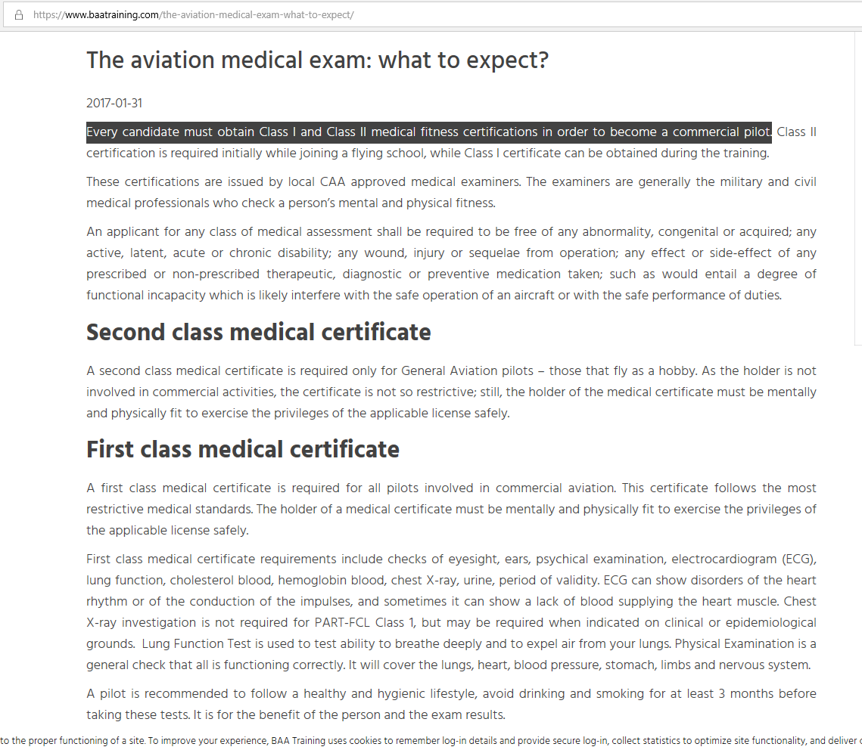

Army pre-selection assessment
https://apply.army.mod.uk/how-to-join/joining-process/soldier-recruitment-steps/soldier-assessment
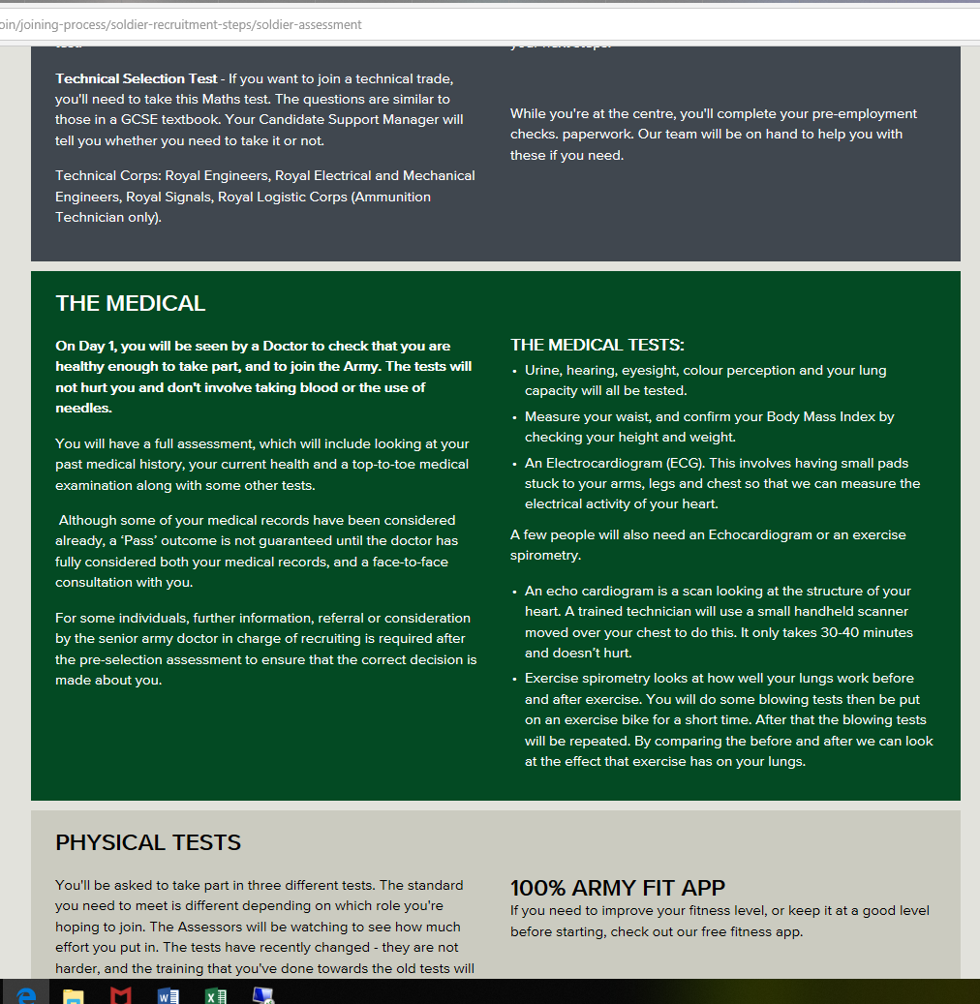
https://www.nhs.uk/conditions/wolff-parkinson-white-syndrome/

